1. Click on <https://www.microsoft.com/en-in/sql-server/sql-server-downloads> .Scroll down cursor.
2. Click on download now at the developer edition. The ".exe” file will be downloaded.

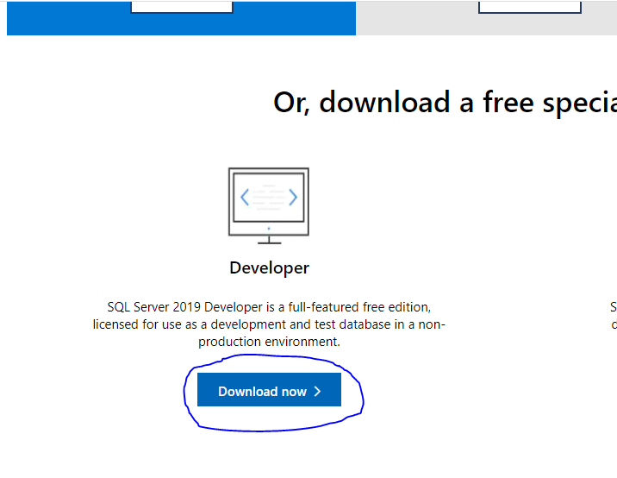

1. Double click on the .exe file. Enter Admin password.
2. Click on “**Basic**”

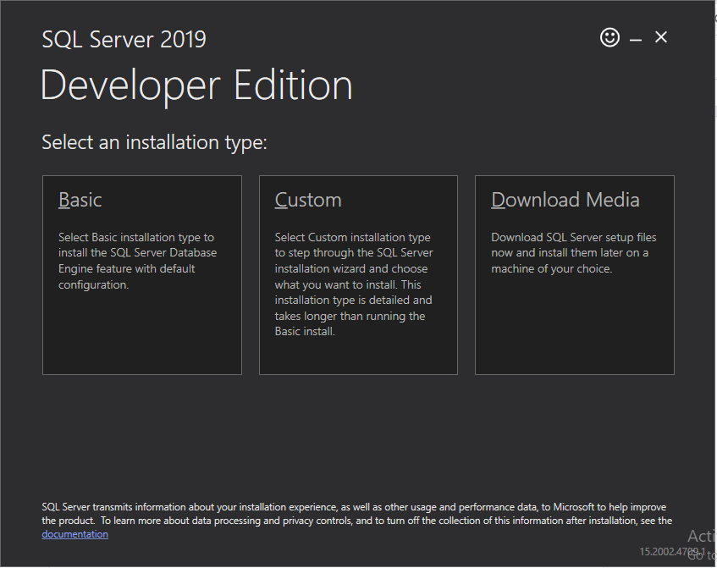

1. Click on “**Accept**” button

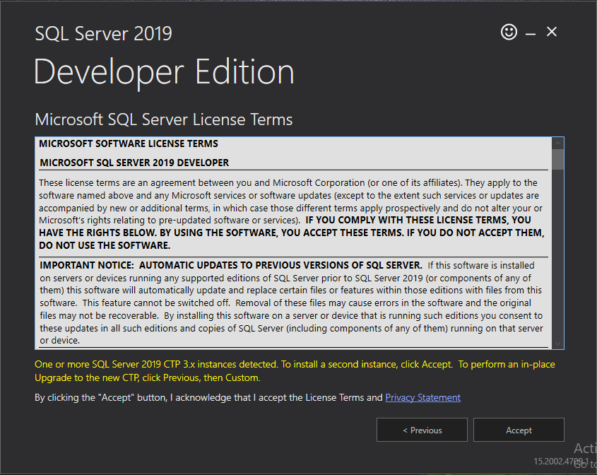

1. Click on “**Install**” button

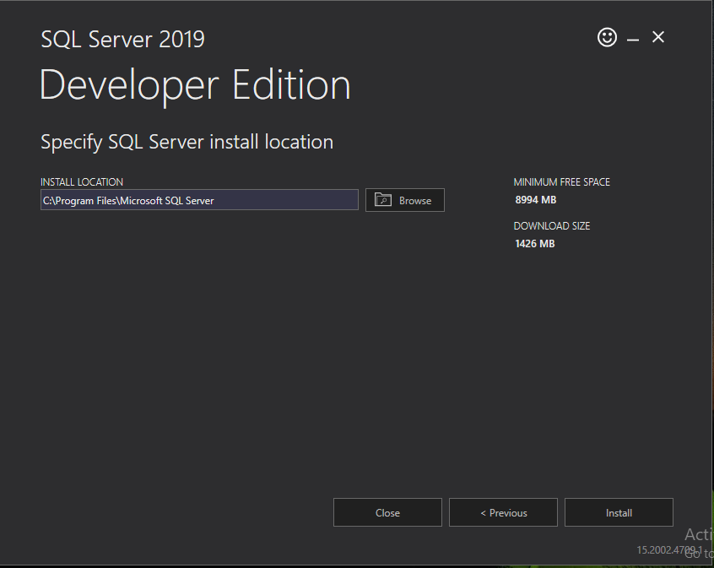

1. Click on “**Install SSMS**” button. It will navigates to “Microsoft” website in browser

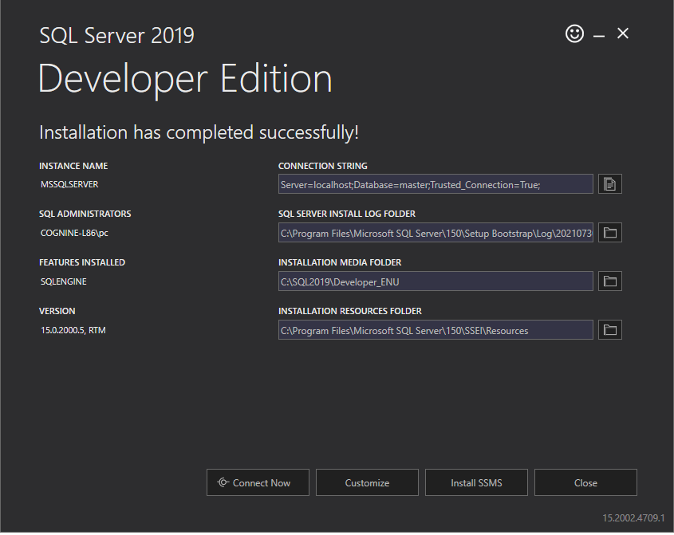

1. Scroll down the cursor. Click on that highlighted link in the screenshot below.

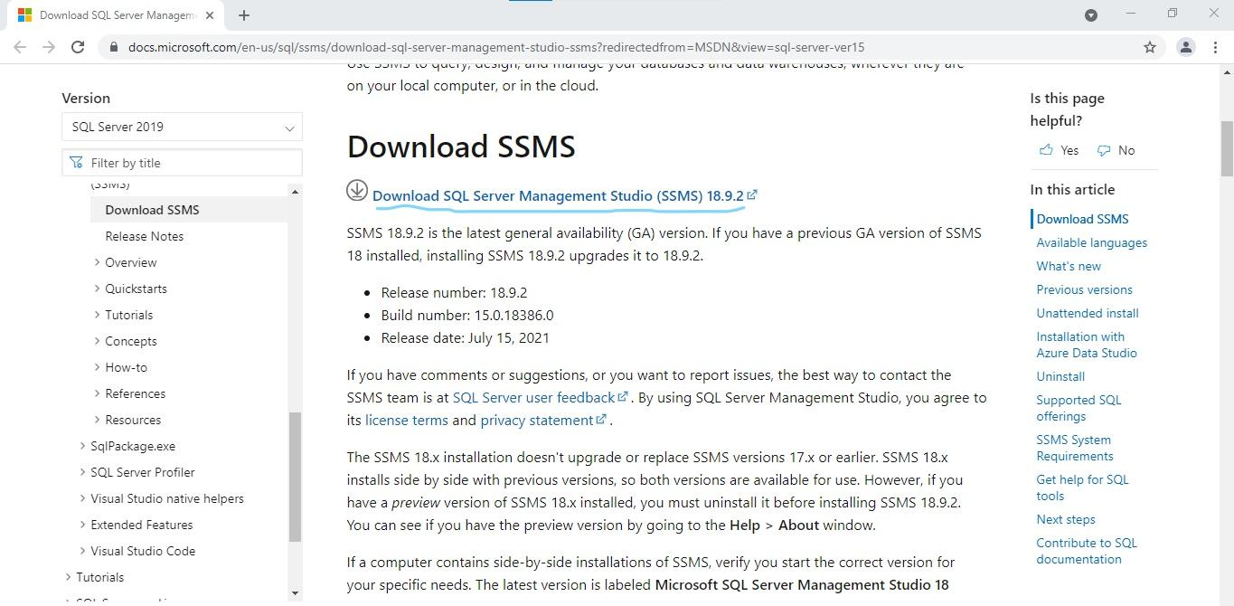

1. The ".exe” file will be downloaded. Double click on that exe file

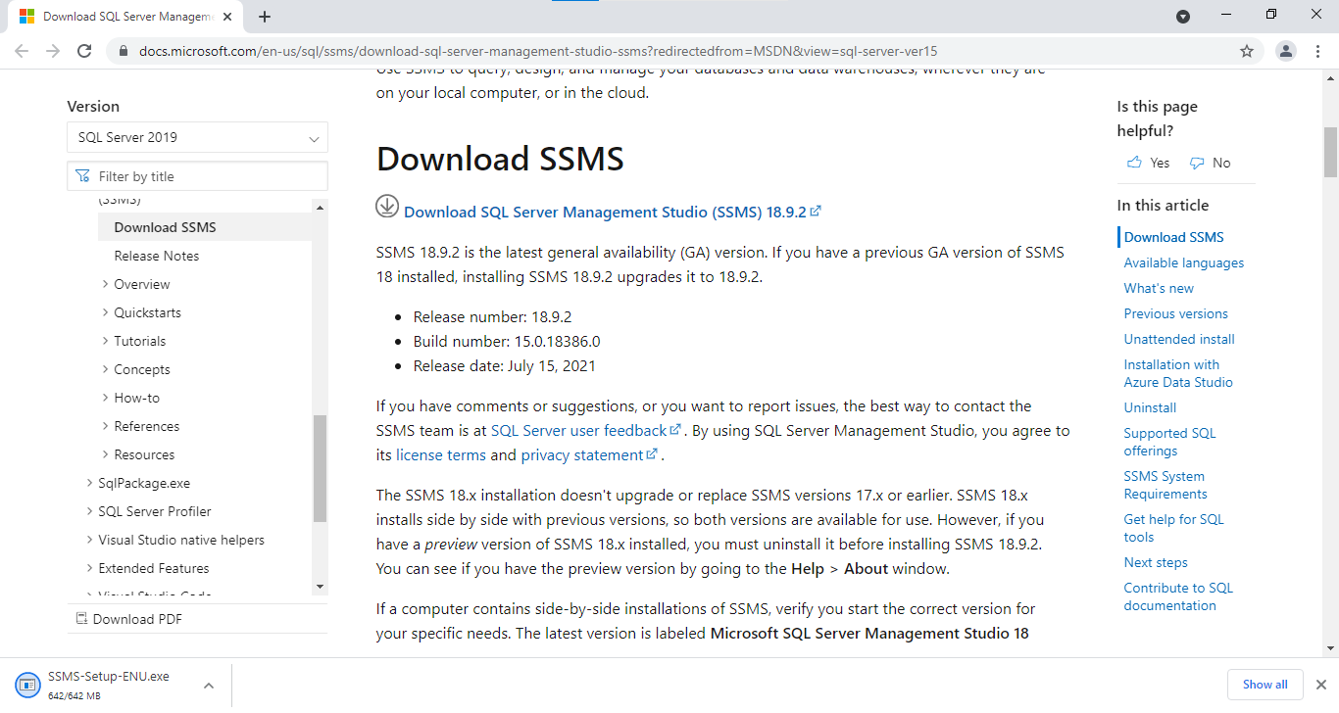

1. Sometimes it will open the “Run” option popup. Click on the “Run” button.
2. Click on “ **Install**” button

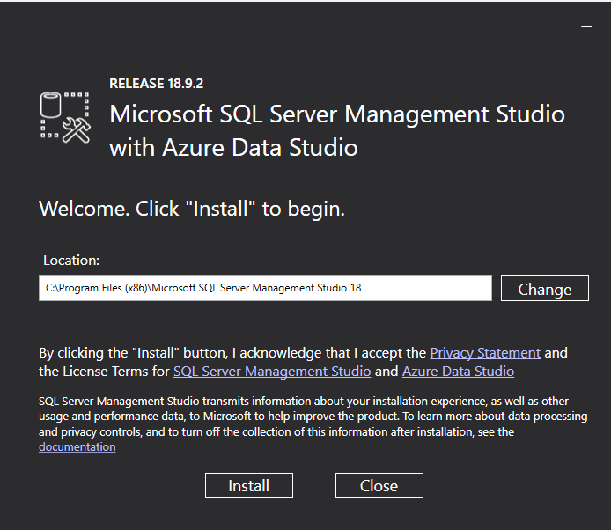

1. Click on “**Close**” button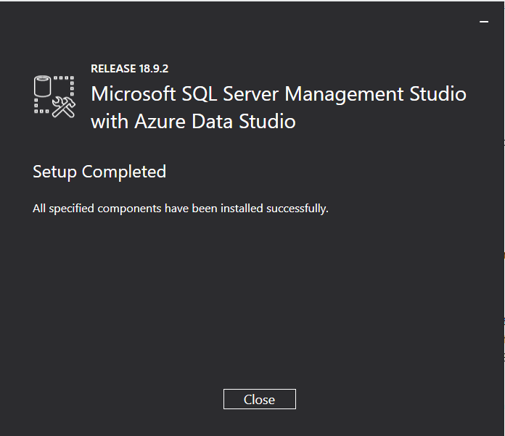
2. Restart the laptop.
3. Go to **This PC >> Windows(C:)**. Double click on the “**SQL2019**” folder .It will ask Admin password. Enter Admin password

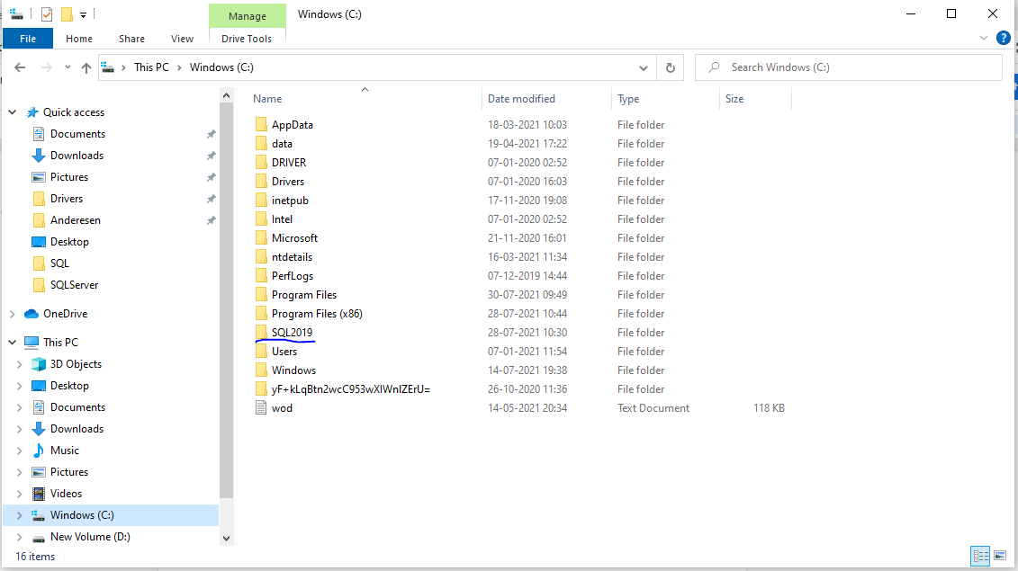

1. Double click on “**Developer_ENU**”.Again it will ask the Admin password.Enter Admin password.

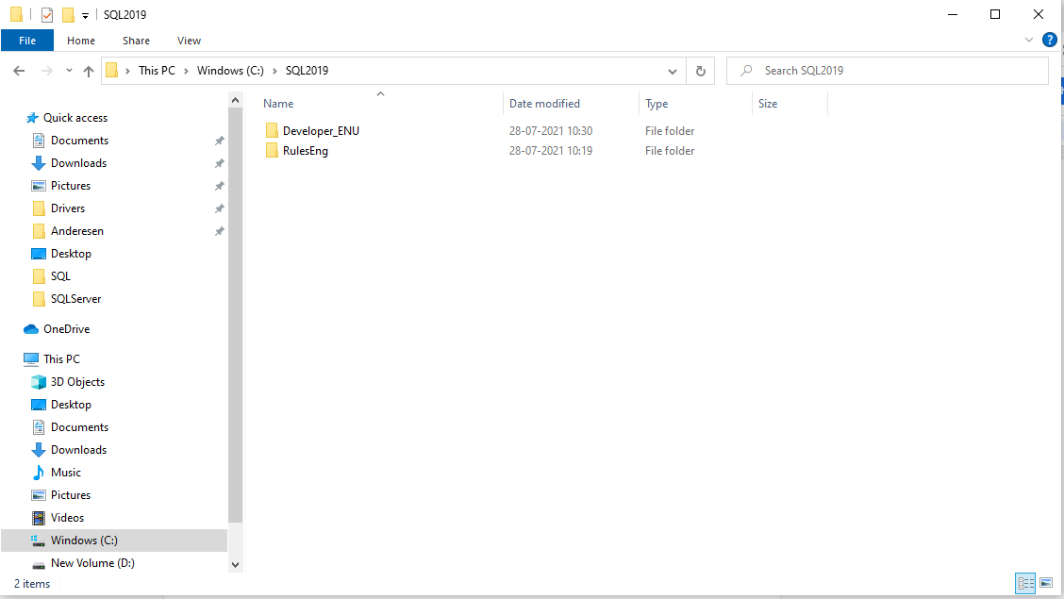

1. Double click on the “**SETUP**” file. It will ask the Admin password. Enter Admin password.

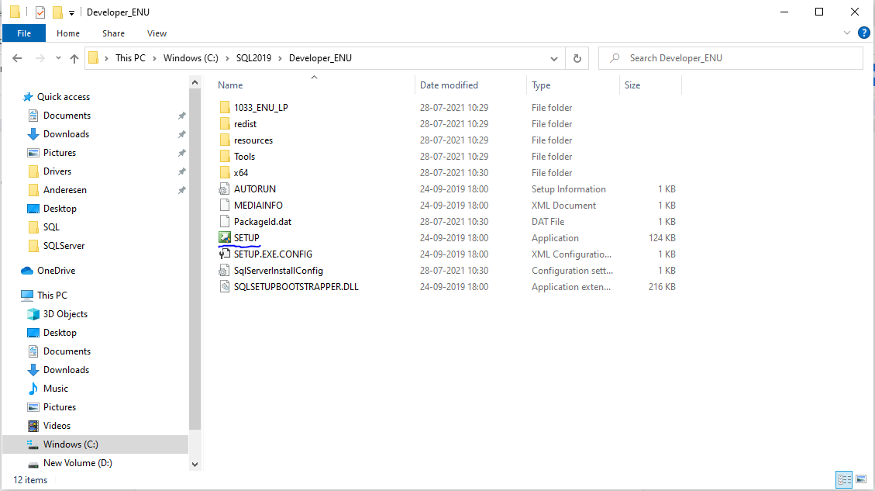

1. Click on “**Installation**” which is at left side

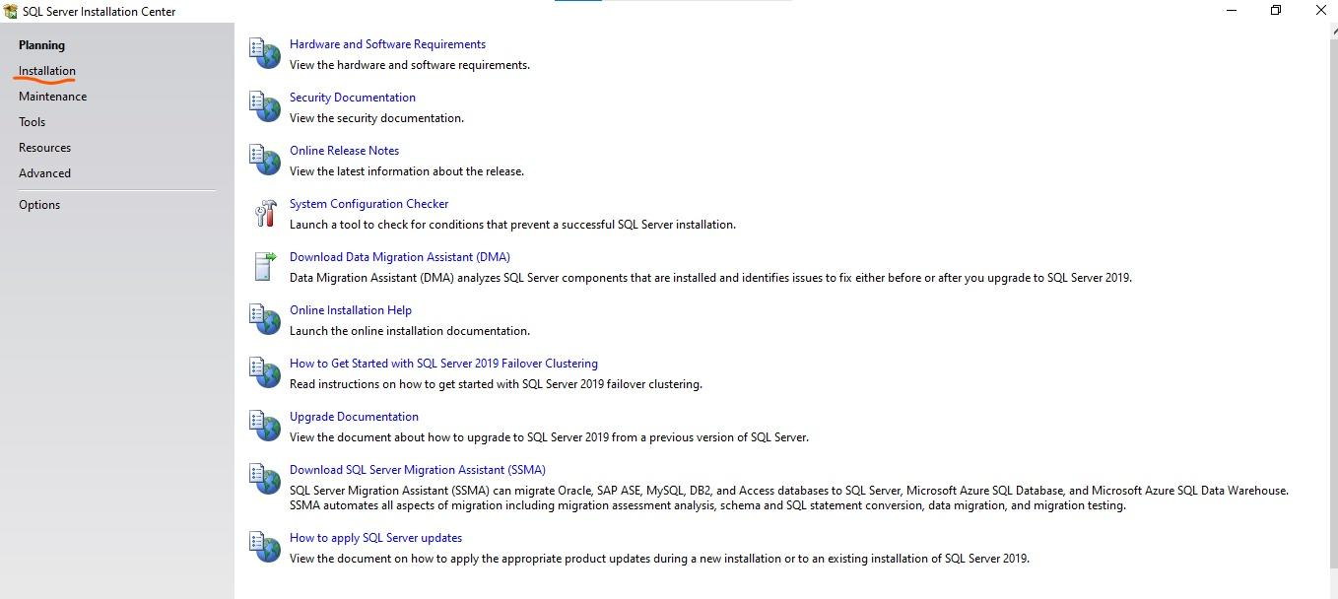

1. Click on highlighted link in below screenshot

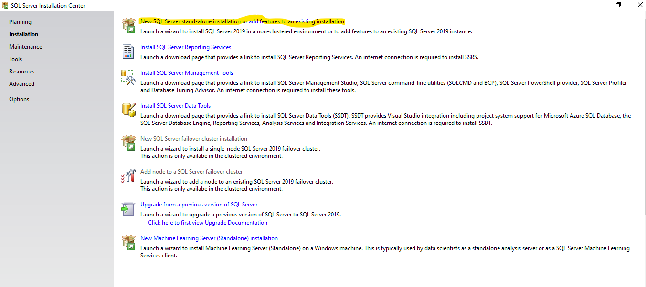

1. Click on “**Next**” button

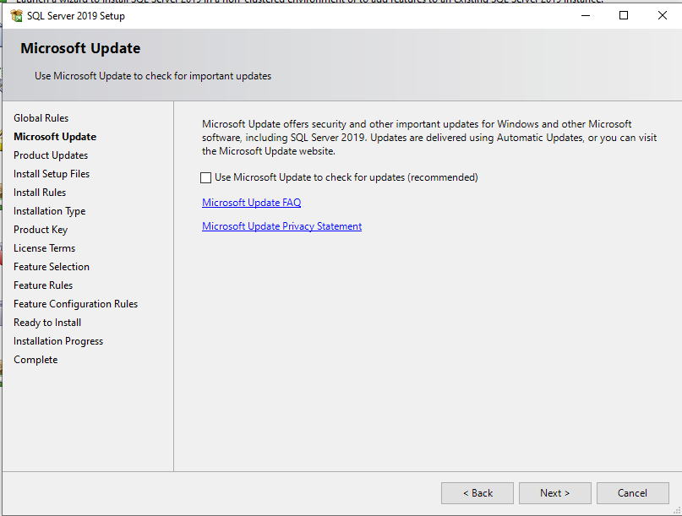

1. Click on “**Next**” button

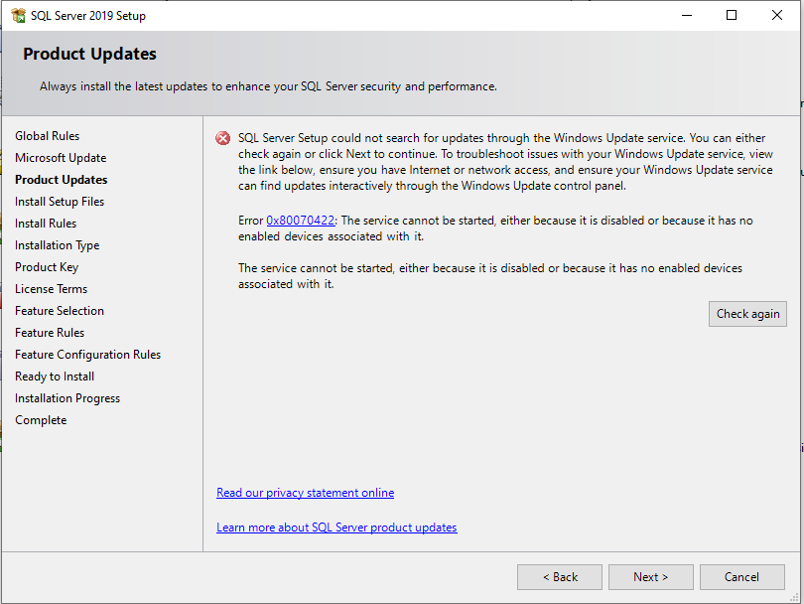

1. Click on “**Next**” button

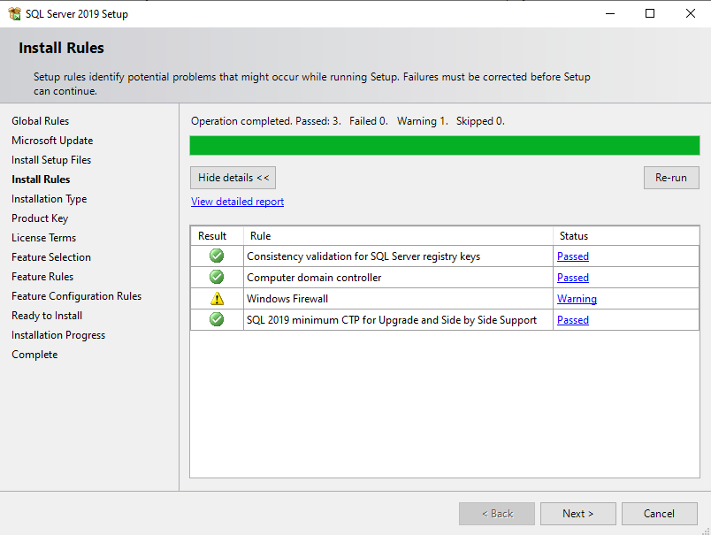

1. Click on “**Next**” button

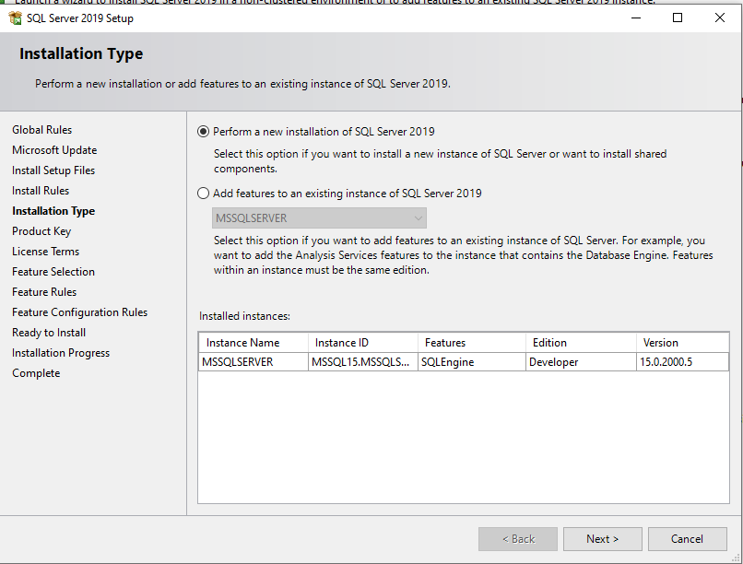

1. Click on “**Next**” button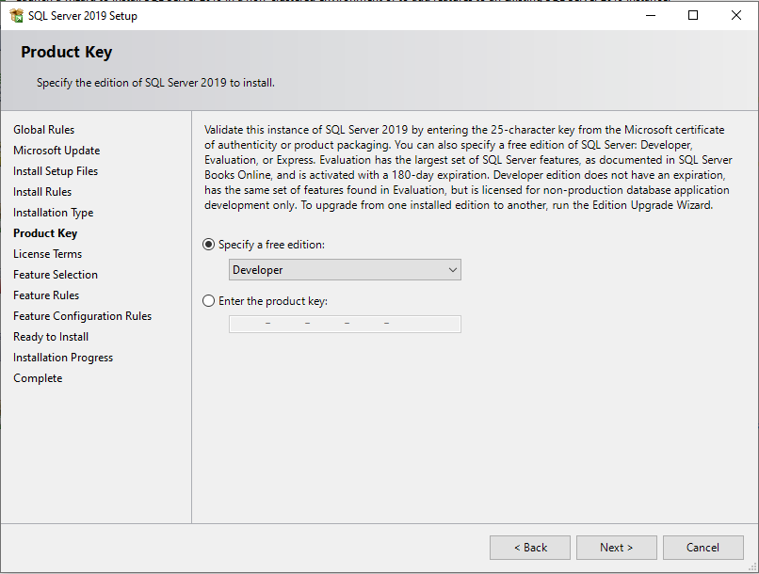
2. Click on the checkbox to accept license terms. And then click on “**Next**” button

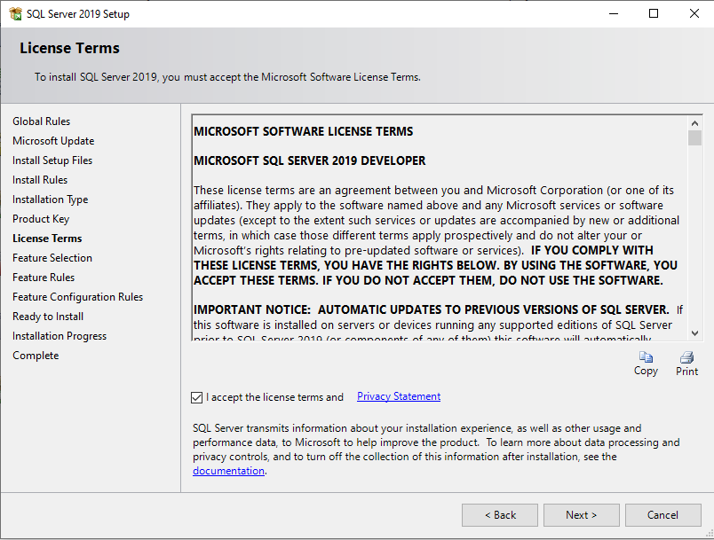

1. Select checkboxes for “**Database Engine Services, SQL server Replication**”. scroll down the cursor. Select the checkbox for “**Analysis services**”.Click on “**Next**” button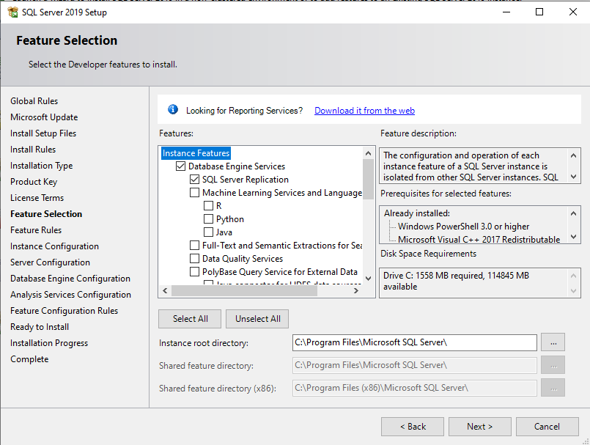
2. Enter “**Named Instance**” as of our choice but without spaces. Click the Instance ID text field , and the automatically named instance will be populated.Click on “**Next**” button.

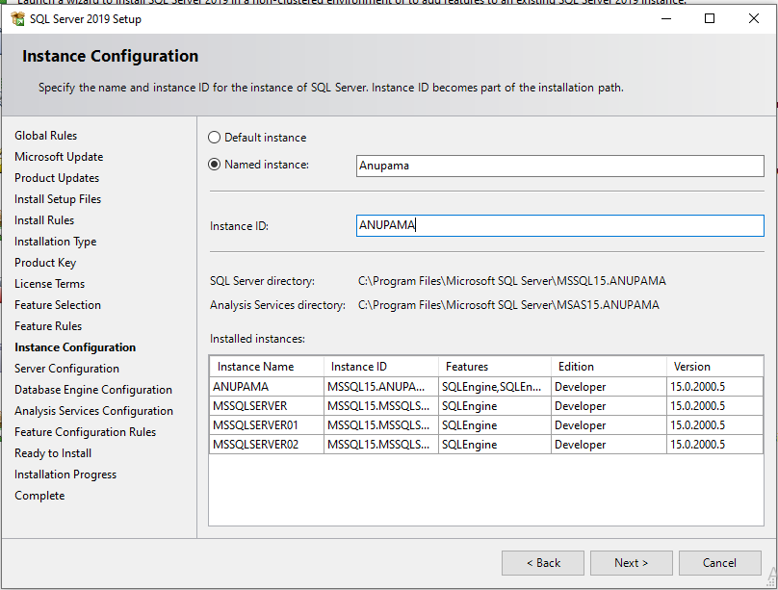

1. Click on “**Next**” button

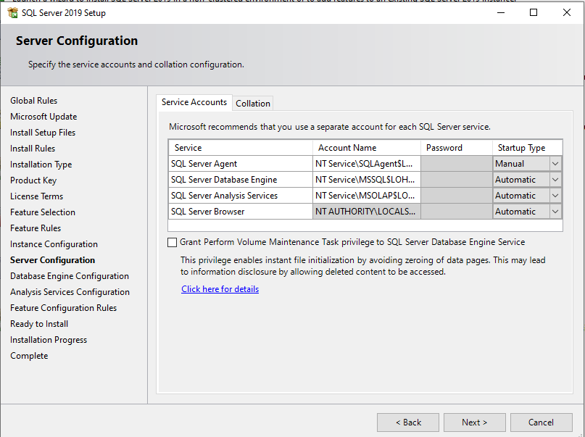

1. Enter “password” and “confirm password”.

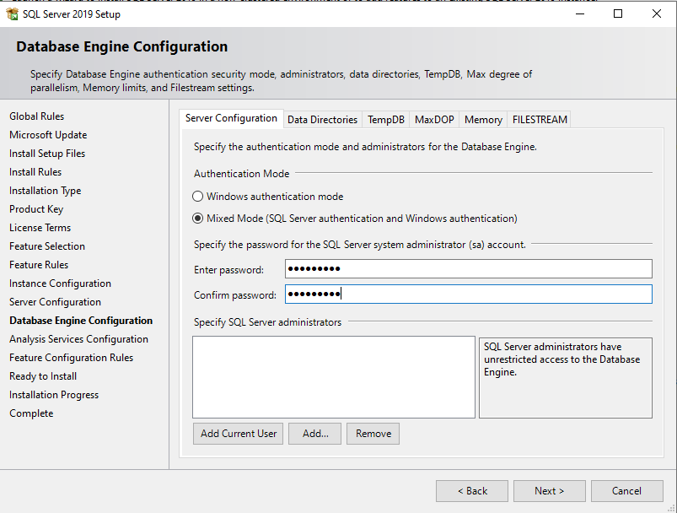

1. Click on “Add Current User” button, Username will be populated in that box.Click on “**Next**” button.

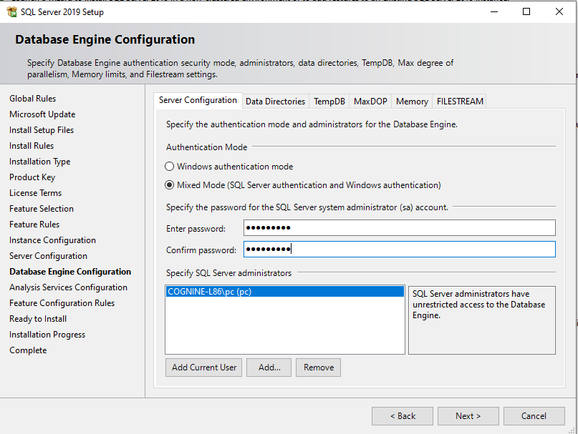

1. Click on “Add Current User” button, Username will be populated in that box.Click on “**Next**” button.

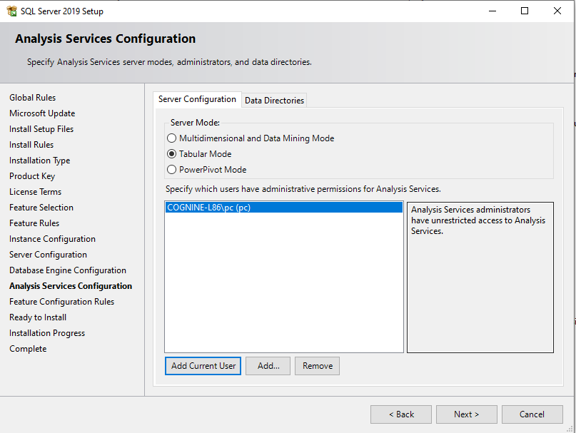

1. Click on the “**Install**” button.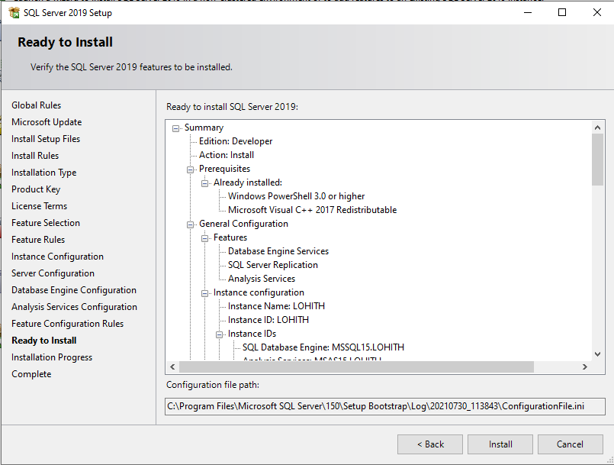
2. Click on “**Close**” button

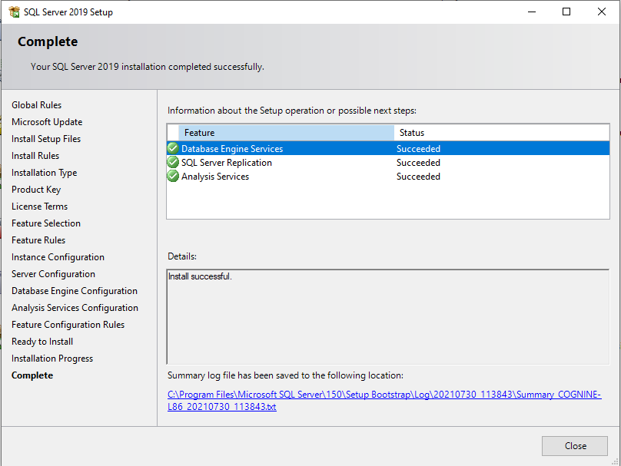

1. Enter “SQL server” in windows search. Double click on the “**Microsoft SQL Server Management Studio 18**”

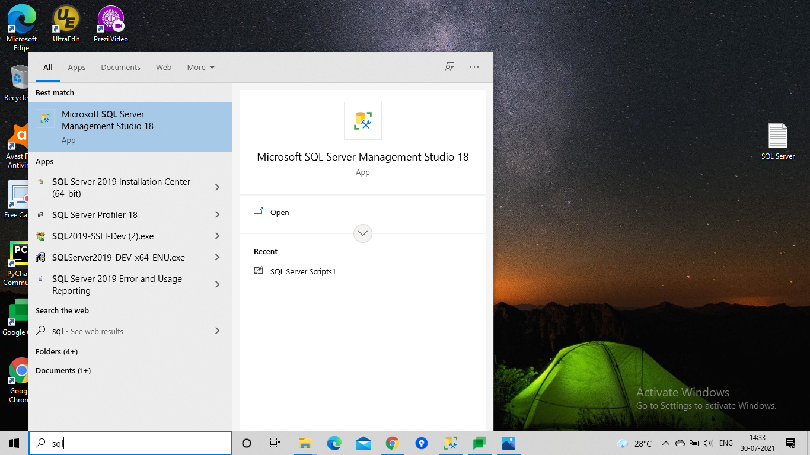

1. Select Authentication as “**SQL server Authentication**”. Enter login as “**sa**” and password.Click on the “Connect” button.

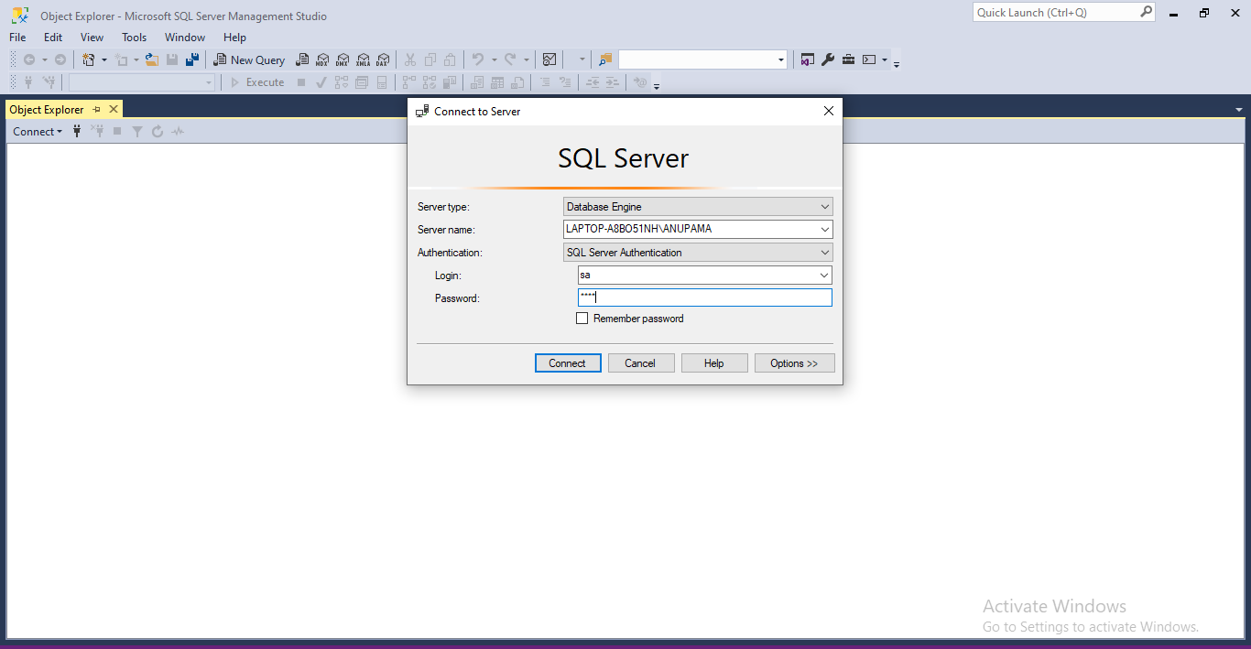

1. Local server will be connected.